Weather Forecasting app

Overview:

A weather forecast is made up of three steps: observation, analysis, and prediction. Weather predictions are created by gathering as much information as possible about the current state of the atmosphere (especially temperature, humidity, and wind) and using meteorology to predict how the environment will evolve in the future.

Goals:

Weather prediction's purpose is to give knowledge that people and organisations can use to reduce weather-related losses and improve societal advantages, such as life and property protection, public health and safety, and economic prosperity and quality of life.

Specification:

Temperature, rain, cloudiness, wind speed, and humidity are all factors to consider. Weather warnings are a type of short-range forecast that is used to protect people's lives.

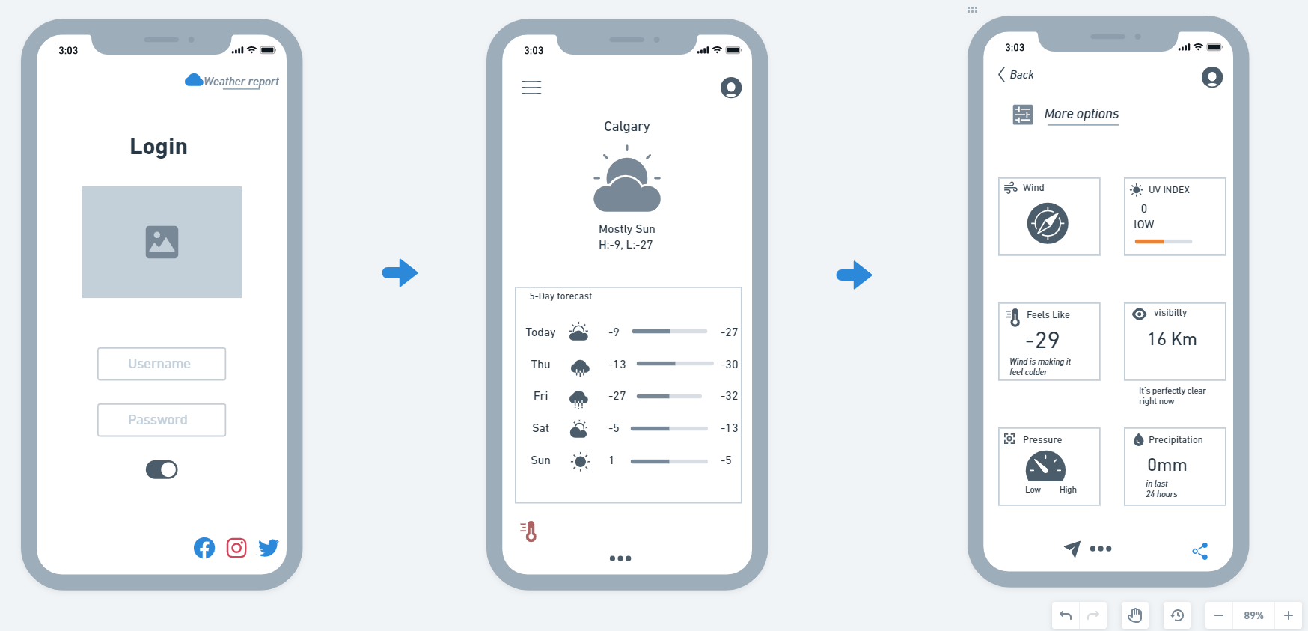

Steps to utilize the application:

To utilise the app's features, the user must first log in with his or her username, email address, and password.

After logging in, there is a weather forecast for up to five days that allows you to see what the weather will be like in the future days.

The final interface displays a variety of additional features such as wind speed, visibility, precipitation, and so on, in order to provide more information about the atmosphere in a certain city or region.